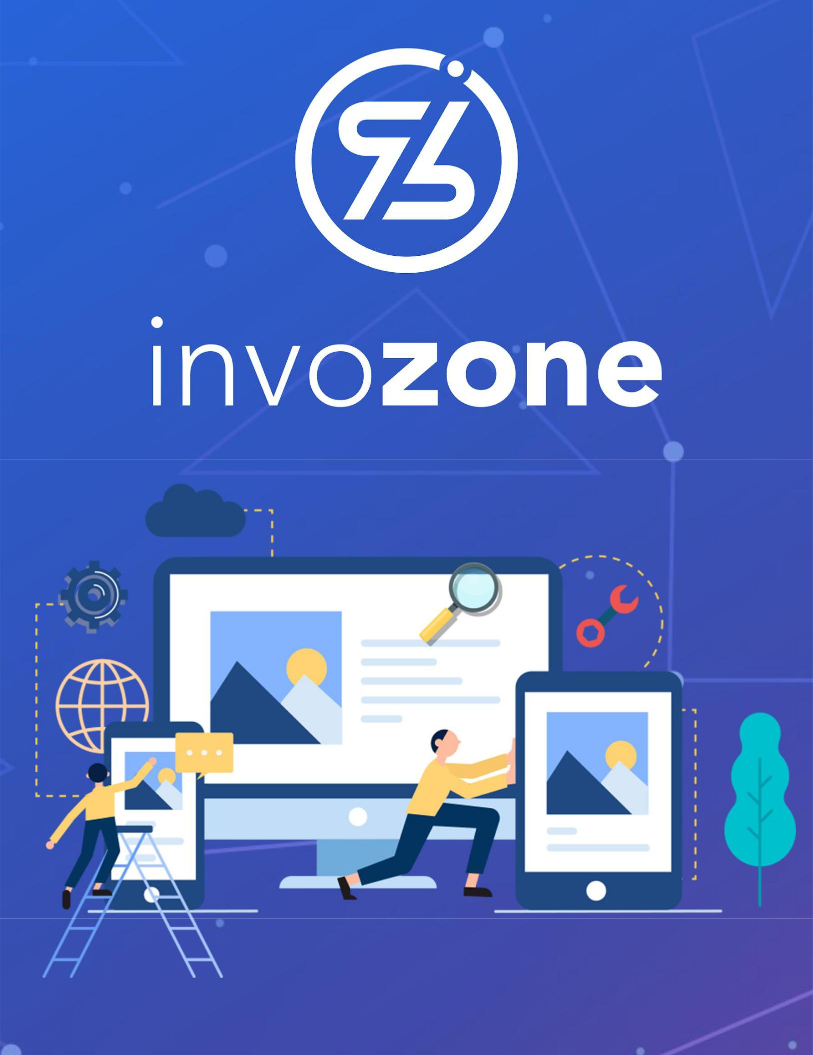

What is Blockchain

READING TASK | 1

## Last Updated: December 28, 2021

# INTRODUCTION TO BLOCKCHAIN

## Introduction & Attributes

Blockchain is a **1)** shared, **2)** immutable, and **3)** Distributed ledger (records) that facilitates the process of recording transactions and tracking assets in a business network. An asset can be tangible (a house, car, cash, land) or intangible (intellectual property, patents, copyrights, branding). Virtually anything of value can be tracked and traded on a blockchain network, reducing risk and cutting costs for all involved.

It would be great if you can go through [This Reading](https://hackernoon.com/blockchain-technology-explained-introduction-meaning-and-applications-edbd6759a2b2), however, the following video is enough as well.

<https://drive.google.com/file/d/1DSMgtYB2eEMZj4oUpHQzLBj_9NuaZjNa/view>

**Blockchain vs Bitcoin (or Cryptocurrency):** Bitcoin, or any other cryptocurrency is just one application of a blockchain, and is built on the blockchain technology. There are multiple other use cases that can be built as we’ll be discussing forward.

### Key elements of a blockchain

* Distributed ledger technology
* Immutable records
* Smart contracts

### How Blockchain Works

* As each transaction occurs, it is recorded and collected in a “block” of data
* The block of data can be added to the blockchain after the verification through ‘consensus’
* Each block is connected to the ones before and after it
* Transactions are blocked together in an irreversible chain: a blockchain

### Benefits of Blockchain

* Greater trust
* Greater security
* More efficiencies

## Architecture & Structure

### Centralized | Decentralized | Distributed

* <https://www.youtube.com/watch?v=64KoIH15j04>

### Cryptography

<https://www.youtube.com/watch?v=5jpgMXt1Z9Y>

<https://www.youtube.com/watch?v=68Pqir_moqA> (BASIC)

* Public Key Encryption

<https://www.youtube.com/watch?v=AQDCe585Lnc>

* Hash Functions

<https://www.youtube.com/watch?v=IGSB9zoSx70>

### Consensus

​​<https://www.youtube.com/watch?v=ojxfbN78WFQ>

<https://www.youtube.com/watch?v=ah94PuwR1DI> (Bonus Not Necessary)

**Mining**

* The process of participating in the blockchain consensus in return for the rewards, (mostly coins)

**Mining Pools**

<https://www.youtube.com/watch?v=btkUUIq-VQs>

PPLNS vs PPS <https://www.youtube.com/watch?v=6WcV4nS4ti0>

### Merkle Trees

<https://www.youtube.com/watch?v=fB41w3JcR7U>

<https://www.youtube.com/watch?v=YIc6MNfv5iQ>